Appendix E-3

Deliverability Evaluation Process Description
for
Fall 2004
Request for Proposals (RFP)
for
Supply-Side Resources

Entergy Services, Inc.
February 22, 2005

SUMMARY

This Appendix E-3 describes the process, criteria, and methods that ESI intends to use to evaluate Candidate Proposal deliverability in this Fall 2004 RFP.

OVERVIEW

The Deliverability Evaluation of the Fall 2004 RFP evaluation process seeks to analyze the potential for utilizing the generation and bulk transmission facilities of the Entergy System to deliver a balanced and diversified portfolio of resources resulting in the highest overall value to customers without materially degrading supply reliability. The methodology for the Deliverability Evaluation is intended to identify whether any constraints exist for resources that are the subject of Candidate Proposals during the Delivery Term prior to the formal submission of any transmission service request to the Transmission Business Unit (TBU). The Candidate Proposals are determined by the economic evaluators in the initial Economic Evaluation and provided to the Transmission Factor Evaluator(s). The Deliverability Evaluation will be performed for Candidate Proposals in the categories of Day-Ahead MUCCO, Intra-Day Peaking MUCCO, and Dispatchable MUCPA products. A partial Deliverability Evaluation will be performed on Candidate Proposals for Three-Year Reserve Capacity MUCCO products. Initially, the Candidate Proposals are evaluated individually and, when applicable, in combination with other Candidate Proposals that have been combined to form one or more Candidate Proposal portfolios.

The Deliverability Evaluation incorporates recent modifications to TBU’s transmission service request processes, namely Available Flowgate Capacity (AFC) implementation, which is based on response factor analysis of pre-defined system constraints termed “flowgates” and has replaced the generator operating limit (GOL) and short-term System Impact Study (SIS) evaluation processes for transmission service requests within an 18-month horizon. The Deliverability Evaluation utilizes publicly available information posted on TBU’s OASIS website (http://oasis.e-terrasolutions.com/OASIS/EES). The AFC-based deliverability methodology identifies constraints that may occur when a newly added resource imposes transmission flows that exceed transmission limits. If a proposal has no constraints identified for the Delivery Term, no further studies or mitigation strategies will be tested in the initial Deliverability Evaluation. If there are constraints indicated for a proposal, however, the Deliverability Evaluation will consider different mitigation strategies as options for relieving the constraints in a least-cost and viable way. These mitigation strategies, which are described in the following sections and illustrated in the appendices, consider the prioritization of existing transmission capability usage and associated cost impacts through the following:

- Delisting and/or displacement of existing network resources,
- Counter-flow generation portfolio selection, and
- Active transmission service management.

Each mitigation strategy will be tested for each Candidate Proposal resource, except the Three-Year Reserve Capacity MUCCO and LD proposals. Due to the nature of the LD product and the lack of a specified generating resource, LD resources will not be evaluated through the Deliverability Evaluation. In addition, only the delisting mitigation strategy will be applied in the evaluation of Three-Year Reserve Capacity MUCCO products because the main purpose of this product is to displace existing generation.

Costs associated with each mitigation strategy will be compared, and the cost associated with the least cost alternative mitigation strategy will be subtracted from the economic benefits of the Candidate Proposal identified in the initial Economic Evaluation, resulting in a net benefit value for each Candidate Proposal. These mitigation cost adders, which are described for each mitigation strategy in the appropriate sections, are not paid by Bidders but are decremented from the respective proposal’s economic benefit in the economic evaluation process, which is designed to compare all proposals in an equitable manner.

After the Deliverability Evaluation, the economic evaluation team will develop an adjusted expected net benefit of each Candidate Proposal based on least-cost mitigation strategy for the respective proposal. The economic evaluation team will then evaluate combinations of Candidate Proposals to identify portfolios of Candidate Proposals that result in the largest expected production cost benefits. The portfolios will be provided to the Transmission Factor Evaluators to determine if the output of any portion of each portfolio is restricted during specific months due to one or more Candidate Proposals imposing transmission flows that exceed transmission limits for such months. The Deliverability Evaluation of the Candidate Proposal portfolios will evaluate the monthly capacity deliverability of each portfolio using the same monthly loadflow cases used for the individual Candidate Proposal analysis. After considering the economic impact of any reduction in total monthly portfolio capacity deliverability, the economic evaluation team will review the production cost savings of each portfolio to determine the overall expected net benefit.

Upon execution of a Definitive Agreement, ESI will request transmission service for the resource from TBU. The requests will be submitted in a sequence that ESI determines would have the highest chance of receiving approval with the least amount of mitigation measures.

Given the nature of LD Products, the value of LD Product proposals will not be affected by any Deliverability Evaluations, and thus no studies will be requested or performed, and there will be no related contingencies in the Definitive Agreement.
For the Three-Year Reserve Capacity MUCCO product, only a three-year request for network transmission service will be submitted. Definitive Agreements for the Three-Year Reserve Capacity MUCCO product will be contingent on Transmission Service Study Results from TBU being received by and being acceptable to ESI in its sole and absolute discretion, no later than 30 days prior to the commencement of the Delivery Term.

In the event that TBU’s Transmission Service Study Results (a) indicate unacceptable results including but not limited to: (i) a denial of transmission service, (ii) new transmission constraints that require upgrades, or (iii) transmission constraints that require delisting and/ or additional counter-flow purchases in excess of the result in the initial Deliverability Evaluation, or (b) are not received by ESI within 30 days prior to the commencement of the Delivery Term, then the Definitive Agreement for the Three-Year Reserve Capacity MUCCO product will not become effective.

For the Day-Ahead MUCCO, Intra-Day Peaking MUCCO, and/or Dispatchable MUCPA products, the requests for network transmission service will be submitted in the following manner. For one-year Delivery Terms, ESI will submit (a) monthly network transmission requests for each month of the Delivery Term that transmission service can be requested through the AFC submittal process, and (b) a long-term request to obtain service for all remaining months of the Delivery Term. For three-year Delivery Terms, ESI will submit (a) monthly network transmission requests for each month of the Delivery Term that transmission service can be requested through the AFC submittal process, (b) a long-term request for the remaining months of the first year, and (c) a long-term request for the second and third years of the Delivery Term.

For the Day-Ahead MUCCO, Intra-Day Peaking MUCCO, and/or Dispatchable MUCPA products, once a Definitive Agreement has been executed, ESI will assume all transmission risk and manage transmission shortfalls (e.g. periods when transmission capacity is not available) for Contract Capacity delivery during the first year of the Delivery Term. The second and third year of the Delivery Term will be contingent on the Transmission Service Study Results from TBU, or on the results of a subsequent Deliverability Evaluation (see Section 4 in the RFP document). ESI will submit the second and third year transmission service requests as annual requests. The Transmission Service Study Results will be shared with the respective counter party, if such results are received by ESI within 255 days from the execution of the applicable Definitive Agreement. If the TBU’s Transmission Service Study Results (a) indicate unacceptable results including but not limited to: (i) a denial of transmission service, (ii) transmission constraints not previously identified in the Deliverability Evaluation that require upgrades, or (iii) transmission constraints that require delisting and/ or additional counter-flow purchases in excess of the result in the initial Deliverability Evaluation, or (b) are not received by ESI within 255 days from the execution of the applicable Definitive Agreement; , then ESI will perform a new Deliverability Evaluation and will re-evaluate the deliverability of the specific resource(s) using the AFC analyzer and AFC load flow cases.

In the event that TBU’s Transmission Service Study Results (a) indicate unacceptable results as described above, or (b) are not received by ESI within 255 days from the execution of the applicable Definitive Agreement; and the new Deliverability Evaluation is not acceptable to ESI in its sole and absolute discretion, then ESI shall notify Seller within 270 days after the execution of the applicable Definitive Agreement for such Day-Ahead MUCCO, Intra-Day Peaking MUCCO, and/or Dispatchable MUCPA products that it has elected to terminate the transaction for the second and third year of the Delivery Term. Any such decision by ESI to terminate the second and third year of the Delivery Term will be explained to and reviewed with staffs of interested state and local regulators.

Constraint Identification

The first twelve months of the Delivery Term for each Candidate Proposal or portfolio will be studied using TBU’s AFC analyzer and the last 12 of 18 monthly loadflow cases, which are posted on the TBU OASIS website and, as such, available to all registered market participants. Results of the AFC analysis may indicate that the contract capacity for the Candidate Proposal is available during the first year of the Delivery Term. In this case, no further Deliverability Evaluation is performed, and no mitigation cost is subtracted from the production cost benefit. If the results of the AFC analysis indicate that constraints exist, the Transmission Factor Evaluator will document all constrained flowgates that must be mitigated, for evaluation purposes, through one of the mitigation strategies.

Figure E3-1 shows an example of constraint identification.

Mitigation Strategies

2.1 Delisting/Displacement
An analysis will be conducted to determine whether constraints identified during the AFC analysis could potentially be mitigated by delisting/displacing network transmission service associated with some portion of the Entergy Operating Companies’ existing network resource generation. Generation options for potential delisting and/or displacement will be identified among those which are expected to have less value to customers than the proposal resource. Coal and nuclear baseload resources will not be delisted. A matrix of response factors will be developed for each delisting/displacement candidate and each Candidate Proposal relative to specific transmission constraints identified for that Candidate Proposal during the AFC-based analysis. Only constrained Candidate Proposals that satisfy the pre-established threshold criteria, referenced in Section 3, for resolving all constraints identified during the AFC-based analyses will be retained for further delisting/displacement consideration. Delisted/displaced resources will be limited to two plants.

Figure E3-2 shows an example of the delisting/displacement analysis.

The Transmission Factor Evaluator will provide the amount of capacity constrained, if any, by month and the delisted capacity, if any, required in the respective month for each Candidate Proposal to the economic evaluation team, which will calculate a delivery cost adder.

2.2 Counter Flow
An assessment of the potential for using “counter-flows” to mitigate transmission delivery issues created by a Candidate Proposal will be made by simulating the impact of future transmission service requests for resources that create “counter-flows” on the constrained transmission facilities.

The “pool” of potential counter-flow resources and their respective response factors to AFC flowgates will be developed for use as potential counter-flow resources. The “pool” of potential counter-flow resources will be based on resources available to the Entergy Control Area with the exception of any Entergy Competitive Affiliates or those owned by the Entergy Operating Companies and not in retail rate base or capacity awarded through previous RFPs. The expected dispatch availability, i.e., capacity type of all counter-flow resources, must be expected to overlap all dispatch periods during which the Candidate Proposal would be constrained. Counter-flow resources will be limited to units at two plants, cannot exhibit AFC constraints during constrained periods identified for the proposal’s Delivery Term, and must completely alleviate flowgate constraints to facilitate obtaining transmission service.

Figure E3-3 shows an example of the counter-flow analysis.

The Transmission Factor Evaluator will provide the months, if any, and the counter-flow capacity required in the respective months for each Candidate Proposal to the economic evaluation team, which will calculate a delivery cost adder.

2.3 Active Transmission Management
The active transmission management mitigation strategy will be evaluated for Candidate Proposals to determine the mitigation cost implications of obtaining transmission service through the use of short-term or subsequent requests for longer-term transmission service. Constrained months will be determined for each Candidate Proposal based on TBU’s AFC analyzer results that list any months that network transmission service is unavailable. Only constrained proposals that satisfy the pre-established threshold criteria, described in Section 3, for all constraints identified during the AFC-based analyses, will be evaluated for active transmission service management.

Figure E3-4 shows an example of the active transmission management analysis.

Threshold Criteria

Since the AFC analyses reflects a single-hour “snapshot” evaluation assuming certain transmission study conditions existing at the time of the proposal evaluation, it is possible that, after proposals are selected; the transmission service studies for the selected proposal resources – carried out by the TBU part of actual transmission service requests for those resources – may indicate different results. The Deliverability Evaluation seeks to quantify the uncertainty and risk associated with alternative transmission service provisioning plans by applying “threshold criteria”, which are conditions that indicate the relative viability of each Candidate Proposal for one or more transmission constraint mitigation strategies. The established “threshold criteria” are resource attributes, such as response factors, which intrinsically encompass such characteristics as:

  - the voltage level of resource interconnection (230 kV or EHV),
  - physical proximity to Entergy System load centers and candidate delisting/displacement resources,
  - magnitude of proposal and available transmission service (MW), and
  - the availability of market supply resources offering potential supply options to offset flows on constrained transmission facilities created by the proposal resource.

These threshold criteria will be evaluated for each transmission constraint mitigation alternative and will provide ESI with some indication that proposed resources which exhibit certain specified locational or electrical characteristics can ultimately achieve transmission deliverability sufficient to achieve the expected benefits of the proposal through use of transmission constraint mitigating alternatives. If one or more transmission constraint mitigation alternatives appear viable, based upon “threshold criteria” and associated evaluation methods, ESI may be willing to assume certain transmission service risks – provided that appropriate options to mitigate potential delivery risks can be identified, appropriately valued, and implemented in a manner that provides reasonable assurance that the economic benefits of proposals will be preserved during the Delivery Term.

Individual Candidate Proposal Evaluation Process

4.1 Study Approach
The study will be conducted in the following sequence:
- The first twelve months of the Delivery Term for the Candidate Proposals will be studied individually using TBU’s AFC analyzer and the last 12 of 18 monthly loadflow cases available to all market participants. If the Candidate Proposal is unconstrained, then no further analysis will be performed by ESI at that time. If the TBU’s AFC analyzer shows constraints, the last 12 of 18 monthly loadflow cases will be studied using the MUSTTM software.
- A generation shift factor table will be created for the constrained flowgate(s) found in each month. For Candidate Proposals with a three-year Delivery Term, it will be assumed that the same months constrained in the first 12 months will repeat in the second and third year of the Delivery Term. If a budgeted upgrade has been posted on OASIS, then it will be considered in the transmission evaluation.
- The mitigation strategies will be evaluated including all AFC flowgates to determine the least cost constraint mitigation strategy for each Candidate Proposal.
- The lowest cost adder will be incorporated into the economic evaluation process.
- The economic evaluation team will compare the Candidate Proposals based on the production cost benefit net of the deliverability cost adder.

4.2 Software Models Used
TBU’s AFC analyzer and the Managing and Utilizing System Transmission (MUSTTM) program will be used for all DC-based loadflow and contingency analyses. The MUSTTM program uses a DC-based network model to assess transmission overloads due to the injections of the Candidate Proposals.

TBU’s AFC analyzer is available for use by all registered market participants at TBU’s OASIS website http://oasis.e-terrasolutions.com/OASIS/EES. MUSTTM is commercially available from Shaw Power Technologies, Inc. (http://www.shawgrp.com/PTI/software/must/index.cfm). The monthly load flow cases, which are used to populate the AFC analyzer, are downloadable from TBU’s OASIS website.

4.3 Deliverability Evaluation Results
The results of the individual Candidate Proposal evaluation process are considered to be confidential and proprietary and will not be shared with Bidders, unless ESI is required to do so as further explained in Appendix F, Section 4.

Portfolio Evaluation Process

5.1 Study Approach
The study will be conducted in the following sequence:
- The portfolio evaluation will exclude any awarded Three-Year Reserve Capacity MUCCO proposals. As mentioned in Appendix E-1, Section 4.3.4., Three-Year Reserve Capacity MUCCO proposals are contingent upon TBU approval for the entire duration of the Delivery Term. The last 12 of 18 monthly loadflow cases will be studied using the MUSTTM software. The monthly load flow cases for this period, which are available to any market participants via TBU’s OASIS website, will be downloaded by the Transmission Factor Evaluator from TBU’s OASIS website for use in this Deliverability Evaluation.
- If the portfolio is unconstrained, then no further analysis will be performed and the portfolio will receive full credit for the benefit estimated in the production cost analysis.
- If the portfolio is constrained, then the total portfolio capacity will be decremented on a pro-rata basis in the production cost savings analysis, during the month in which the portfolio is constrained, to reflect the limited capacity available.
- After considering the economic impact of any reduction in total monthly portfolio capacity deliverability, the economic evaluation team will review the production cost benefit of each portfolio to determine the overall expected net benefit.

5.2 Software Models Used
The MUSTTM program will be used for all DC-based load flow analyses, economic dispatch simulations, and contingency analyses. The MUSTTM program uses a DC-based network model to assess transmission overloads due to the injections of the portfolios.

5.3 Deliverability Evaluation Results
The results of the portfolio evaluation process are considered to be confidential and proprietary and will not be shared with Bidders, unless ESI is required to do so as further explained in Appendix F, Section 4.
ILLUSTRATIVE

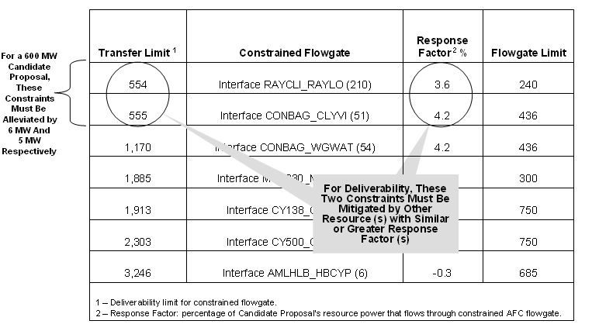
ILLUSTRATIVE

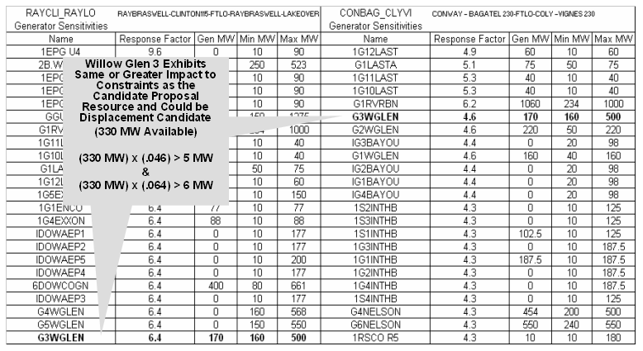

ILLUSTRATIVE

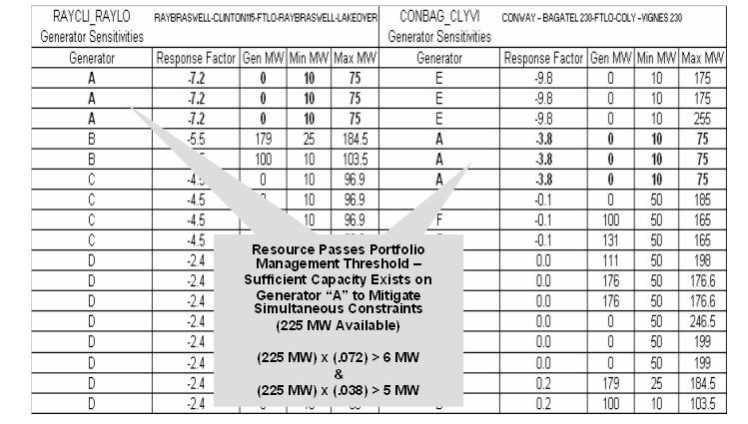

ILLUSTRATIVE

Response factor is the percentage of a Candidate Proposal resource’s power output that flows through a constrained transmission element due to the resource’s location and the System’s transmission network topology.
As described further below, for the Day-Ahead MUCCO, Intra-Day Peaking MUCCO, and Dispatchable MUCPA Products, if ESI executes Definitive Agreements for a Delivery Term of three years, ESI will request network transmission for the resource, and if the Transmission Service Study Results are not acceptable to ESI a subsequent Deliverability Evaluation may be performed if necessary. For Three-Year Reserve Capacity MUCCO Products, ESI will rely only on acceptable Transmission Service Study Results, as further described below.
The terms “delisting” and “displacement” refer to study methodologies for evaluating new network resources. In general, a “delisting” study evaluates a new network resource as a long-term substitution for an existing network resource, while a “displacement” study evaluates a new network resource as a short-term substitution for an existing network resource. From Business Practice for Network Resource-Delisting/Displacement Studies posted on OASIS.
Some long-term network transmission requests may be submitted to TBU in anticipation of the execution of a Definitive Agreement.
Transmission Service Study Results means a response from the Entergy Transmission Business Unit to a request for transmission service. Such response may be provided at or near the time a request is initially submitted and/or once a System Impact Study, if required, is performed.
See footnote 2 above.

